Darjeeling Tea – The Champagne of Indian Teas
By The Export Express – Global Exporters of Premium Indian Teas

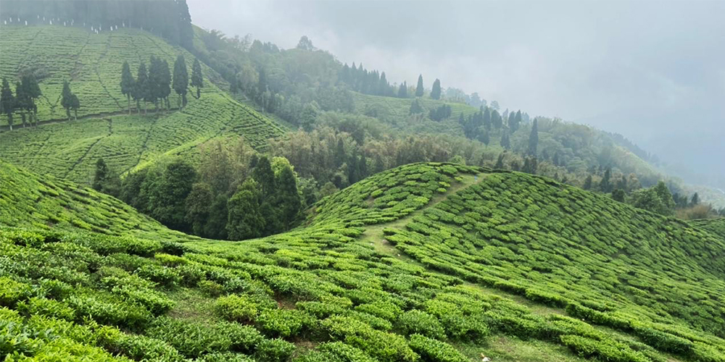

Introduction
Darjeeling Tea is one of the most distinguished and globally recognized teas, often referred to as the “Champagne of Teas.” Cultivated in the picturesque hills of Darjeeling, West Bengal, this tea is celebrated for its delicate aroma, complex flavor, and golden liquor.
Each cup of Darjeeling tea carries a legacy of craftsmanship and natural excellence, representing centuries of tradition combined with modern precision.

Origin and Legacy
Darjeeling sits at altitudes between 600 to 2,000 meters, where cool mountain air, mist, and rainfall nurture the finest tea leaves.
Recognized with a Geographical Indication (GI) tag, authentic Darjeeling tea is cultivated exclusively in the 87 registered gardens of the region. These estates produce teas that are prized worldwide for their muscatel flavor, smooth texture, and floral aroma.

The Flushes – Harvest Seasons of Flavor
Each season, known as a flush, imparts a unique taste and color to the tea.
Flush | Harvest Time | Characteristics | Flavor Profile
First Flush (Spring) | March – April | Early tender leaves, light golden liquor | Floral aroma, brisk, delicate flavor
Second Flush (Summer) | May – June | Matured leaves with muscatel notes | Deep amber liquor, fruity and smooth
Monsoon Flush | July – September | Grown during the rainy season | Strong, bold, less aromatic
Autumn Flush (Fall) | October – November | Late-season harvest before winter | Mellow, sweet, and balanced taste

Types of Darjeeling Tea
Darjeeling teas are classified based on their processing and oxidation levels. Each type offers a distinct sensory experience.

Darjeeling Black Tea
The most traditional and widely exported variety. Fully oxidized, it delivers a rich amber color and muscatel aroma with a slightly sweet finish.
Best suited for: Pure black tea drinkers and gourmet blends.
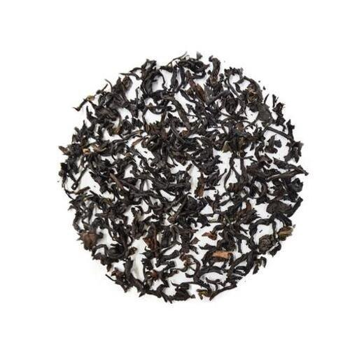

Darjeeling Green Tea
Minimally oxidized and gently pan-fired to preserve its nutrients. Offers a fresh, grassy flavor and light golden infusion.
Best suited for: Health-conscious consumers and daily detox teas.
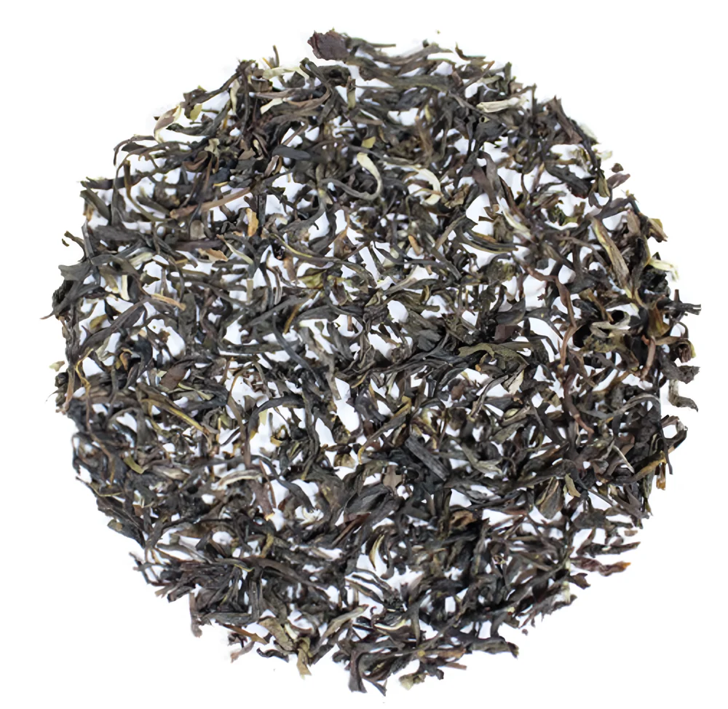

Darjeeling White Tea
Made from young buds and leaves dried naturally in sunlight. Pale golden in color, it provides a delicate, sweet flavor with subtle floral notes.
Best suited for: Premium wellness and luxury tea markets.
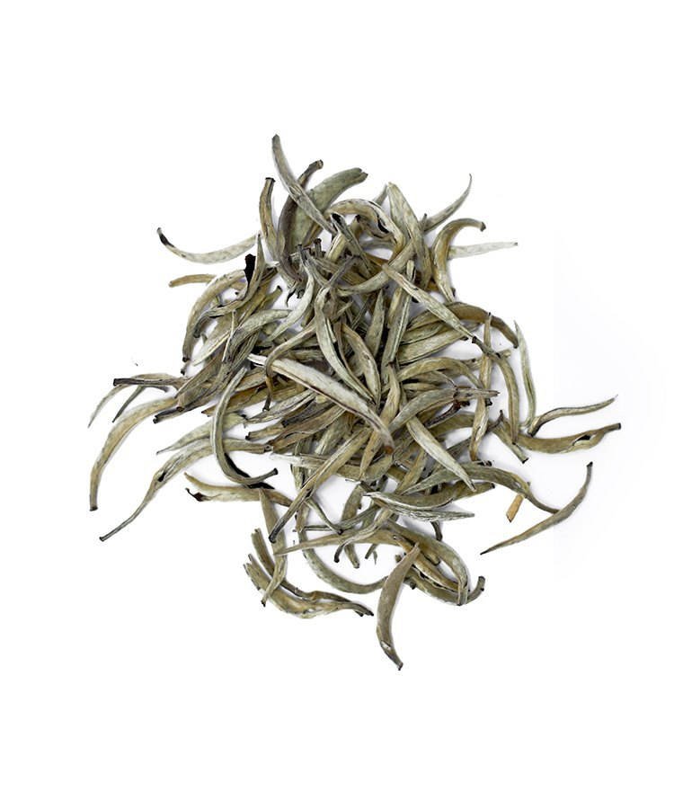

Darjeeling Oolong Tea
Partially oxidized, Oolong tea bridges the gap between black and green teas. It has a smooth, floral, and slightly fruity flavor with a balanced body.
Best suited for: Specialty tea connoisseurs seeking depth and aroma.

Darjeeling Classic Oolong Green Tea by The Export Express
Caption: The Export Express – Darjeeling Classic Oolong Green Tea
The Darjeeling Classic Oolong Green Tea by The Export Express represents a unique harmony between freshness and sophistication. This exclusive blend combines the mellow character of oolong with the vitality of green tea, creating an aromatic and balanced infusion.

Why Choose Darjeeling Classic Oolong Green Tea
- Distinctive Blend: A balanced combination of oolong’s smoothness and green tea’s natural freshness.
- High Quality: Sourced from high-altitude gardens in Darjeeling, handpicked for purity and uniformity.
- Aromatic Profile: Floral and fruity notes with a light, refreshing sweetness.
- Health Benefits: Rich in antioxidants that support digestion, metabolism, and relaxation.
This refined tea is ideal for boutique retailers, premium wellness brands, and export clients seeking authentic Indian teas.

Brewing Guide
Tea Type | Water Temperature | Steeping Time | Quantity
Green Tea | 75–80°C | 2–3 minutes | 1 tsp per cup
Oolong Tea | 85°C | 3–4 minutes | 1 tsp per cup
Black Tea | 90–95°C | 3–5 minutes | 1 tsp per cup
White Tea | 80°C | 4–5 minutes | 1.5 tsp per cup
Tip: Always use fresh, filtered water and avoid over-steeping to retain natural flavor and aroma.

Health Benefits of Darjeeling Tea
- Rich source of natural antioxidants that fight free radicals
- Supports cardiovascular health and improves blood circulation
- Aids digestion and enhances metabolic activity
- Helps in stress relief and mental focus
- Strengthens immunity and promotes detoxification

Global Demand and Export Overview
Darjeeling Tea holds a prestigious position in the global market due to its limited production and unmatched flavor.

Export Highlights
- Country of Origin: India
- Varieties: Black, Green, Oolong, and White
- Shelf Life: 18–24 months
- Certifications: FSSAI, ISO, GMP, Organic Certified
- Packaging Options: 100g, 250g, 1kg, and bulk cartons
Darjeeling tea is particularly sought after in the European Union, Japan, the USA, and the Middle East, where it is marketed as a luxury beverage.

Why Partner with The Export Express
At The Export Express, we are committed to delivering premium-grade Darjeeling teas to global markets.
Our offerings include:
- 100% authentic GI-certified Darjeeling tea
- Custom private labeling and export packaging
- Hygienically processed and quality-tested batches
- Flexible volumes for wholesale and retail supply
We focus on building long-term relationships with tea importers, distributors, and wellness brands worldwide.

Meta Information
Meta Title: Darjeeling Tea – Types, Benefits, and Export from India | The Export Express
Meta Description: Discover authentic Darjeeling Tea varieties – Black, Green, Oolong, and White. Learn about flavors, health benefits, and export opportunities with The Export Express.
Keywords: Darjeeling Tea Export India, Darjeeling Oolong Green Tea, Indian Tea Exporters, Premium Darjeeling Tea

The Export Express – Exporting India’s Finest Teas and Herbal Blends Worldwide.

